The Concept of Anomie

Name
Institution
Course
Instructor
Date

The Concept of Anomie
The concept of anomie is a social condition that transpires where a society's morals and values collapse. The normlessness forces individuals to lack a sense of belonging, disconnecting them from the community (Lau, 2020). In addition to that, anomie occurs after a period of change in society's social, political, and economic fabric.
In the city of Brooklyn, normlessness is best depicted by the increase in dirt bikes roaming the streets. This group of riders poses a threat to the safety of the Brooklyn community, and their continuous presence on the streets of New York is emblematic of normlessness and disorder. The concept of anomie fits well in this discussion because, per Durkheim's argument, anomie transpires in situations where the societal norms and values deemed acceptable during a particular phase are no longer valid (Lau, 2020). At the same time, new values and beliefs are yet to evolve and assume the place of the previous values.

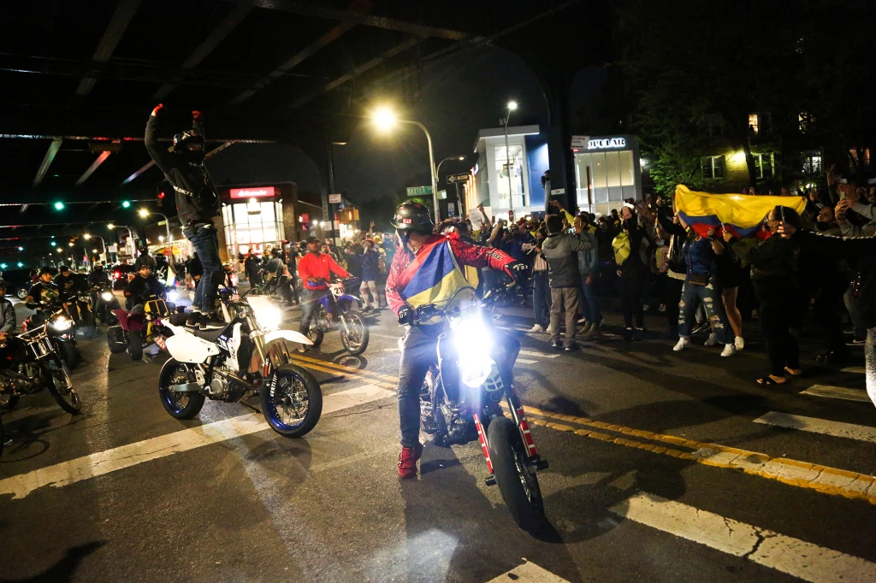
Figure1: Eric Adams calls for city, state crackdown on illegal dirt bikes (2021)
The illegal motorcycle gangs in the streets of Brooklyn are notorious for engaging in illegal bike races and drugs, while the authorities look the other way. People who have lived through times of anomie feel isolated from society because the standards and values they hold dear are no longer reflected in society. This makes them feel as if they do not belong and are not meaningfully linked to people. That explains why some of the residents in Brooklyn decide to join gangs like the biker gangs that are lawless, do not follow traffic rules, and are rowdy on the roads. These entities engage in gang-related activities because they feel accepted, are not judged, and their actions please other gang members. In addition to that, many dirt bike gangs of Brooklyn feel that the system no longer value the role they play (or once played) in the society or their character. In the end, Lau (2020) argues that anomie leads to the development of a sense of purposelessness, inspires despondency, and fosters disobedience and criminal behavior among these individuals. Also, when one examines Durkheim's entire writing on anomie, it is clear that he regarded it as a disintegration of the links that bind individuals together to form a functioning society, a state of social disorder. Because the social power of the values and beliefs that otherwise give stability is reduced or absent, episodes of anomie are volatile, chaotic, and often replete with conflict.
To sum it up, the scenes witnessed with the biker gangs in Brooklyn depicts social disorder. One can ask what the law enforcement officers are doing. A close look at some of the people engaged in this activity reveals that they are disconnected from their families and have found new friends in the bike gangs of Brooklyn. The chaotic scenes in the streets of Brooklyn and the criminal behavior that ensues indicate that society has not provided legitimate methods of achieving collective goals, values, and beliefs. In the end, individuals seek alternatives by simply going against the norms.
References
Lau, T. F. T. (2020). The Concept of Anomie in Explaining Crime. Bellarmine Law Society Review, 11(1).
Raskin, S. (2021, May 26). Eric Adams calls for city, state crackdown on illegal dirt bikes. Https://Nypost.Com/2021/05/26/Eric-Adams-Calls-For-City-State-Crackdown-On-Illegal-Dirt-Bikes/

